Deletion of the User\Login and remove the access to the Oracle user.

Seller Restrictions

The data contained in this document shall not be disclosed and shall not be duplicated, used, or disclosed in whole or in part for any purpose. If a contract is awarded to chosen parties as a result of or in connection with the submission of this data, the client or prospective client shall have the right to duplicate, use, or disclose this data to the extent provided in the contract. This restriction does not limit the client’s or prospective client’s right to use the information contained in the data if it is obtained from another source without restriction. The data subject to this restriction is contained in all marked sheets.
Version Control

All information given under this version over rides all and any kind of offers, assumptions, deliverables and contracts, given under any previous version. All previous versions of the subject Proposal stand null and void.

Revision History
Date | Who | Version | Description
04/03/2017 | Kanchan | 1.0 | Created Initial Draft Document

Version No. | Draft
Date | 04/03/2017
Submitted by | Kanchan
Reviewed by
Approved by | Dharmendra Singh and Tejinder Kaur
Toyota Financial Services

CPU AND MEMORY REPORT

Table of Contents

1. | Goals & Objectives | 3
2. | Environment & Prerequisites | 4
3. | How this script works (help) | 4
4. | Reports | 5
5. | Script | 5

Goals & Objectives

Goal:

PowerShell script to delete user from oracle databases and store information of the user like, name, account status, metadata, profiles and roles/privileges assigned to user. If user is created under service account (user have objects) then lock user account , it should not be deleted.
Else delete the user and remove access of the user from the databases

The connection of PowerShell and oracle is done via tns file. All databases names should be there in the tnsnames.ora file from which user is to be deleted.

Benefits:

After deletion of the user DBA can check what are the roles and privileges were assigned to the user by going through all the information which is retrieved before deletion of the user.

2. Environment & Pre-Requisites:

Environment
- PowerShell 2.0
- Oracle 11g / Oracle 12C

3. How the script works:

This Windows PowerShell script uses various PowerShell command-lets to delete user from Oracle Databases and remove access of the user. The script will keep user information (e.g. when account was created, what are the profiles assigned to it, what is status of the user account) as a backup before deletion of that user. Now check if user has objects then perform these actions:

- Store user roles and privileges in a file.
- Lock the user account in backend.
- Send a mail to DBA team that “This particular user have object so it can’t be deleted , hence it has been locked”

If user doesn’t have any object then perform these actions:
- Store user roles and privileges in a file.
- Delete the user account in backend.
- Send a mail to DBA team that “This particular user have object so it can’t be deleted , hence it has been locked”

An Error log file is generated with current date in case of any error like:

Invalid credential used for a database.
User does not exist.

Reports:

If user have object: lock the user account

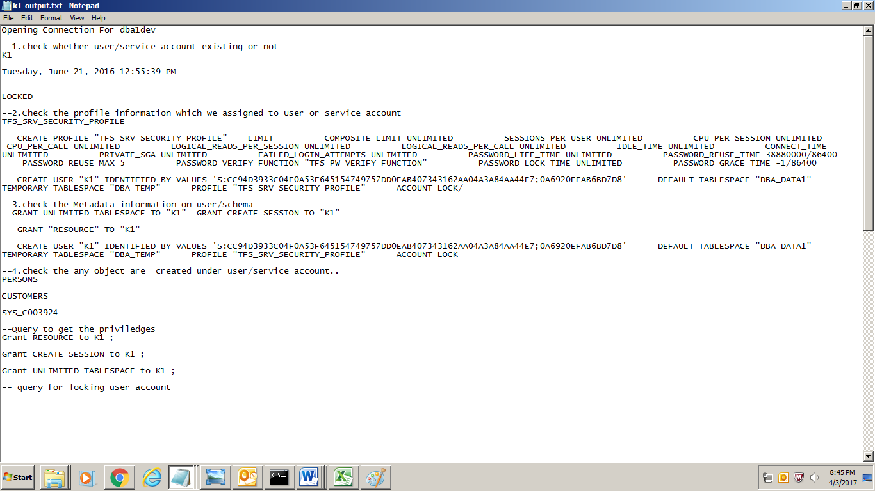

If user does not have object: deletes the user

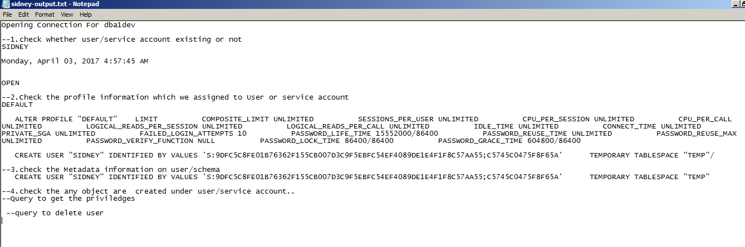

Errorlog file generes in case of any error:

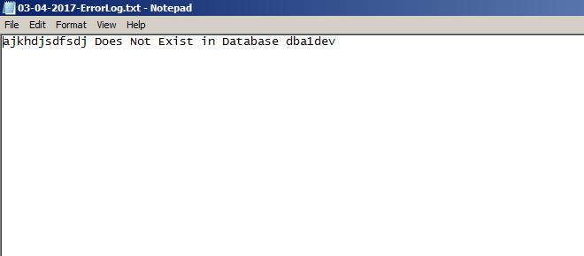

- Scripts:
